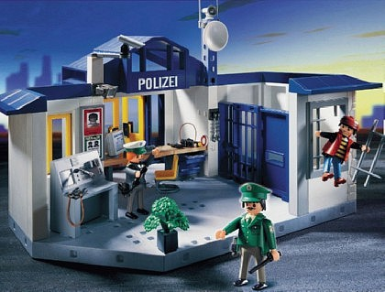
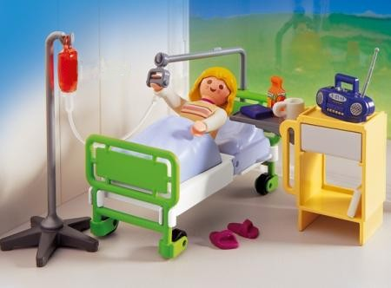
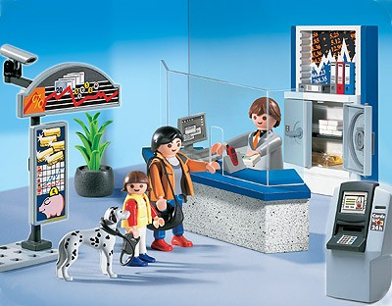
l
banque
commissariat
hôpital

police
hospital
bank
heddlu
ysbyty
banc
polizia
ospedale
banca
poliţia

spitalul

banca

19
20
21
Polizei
Krankenhaus
Bank



