LOMBARD ARTISTS OF THE XX CENTURY,WITH A PARTICULAR REFERENCE TO THE PROVINCE OF COMO.

We are the pupils of 4th class of primary school in Appiano Gentile (Co).
We are going to introduce you some important Lombard artists, above all in province of Como. Although the collapse of our Nation after the first and second World War, there were a lot of progresses in all fields, Art included. Italy sees the birth of an important artistic movement “The futurism”.
These international famous artists wanted to look at the future, breaking off with the past: Boccioni, Balla, Severini, with their futurist paintings in Milan.
In architecture field, a famous artist was Antonio Sant’ Elia from Como.
He published “The Manifesto of futurist architecture” and a series of brilliant projects ispired to the “city of future”.
Great changes were made in the buildings: houses, factories, industries with big sheds, sports estates such as Stadiums, swimming – pools, hippodroms etc. It’s the end of ancient houses called “Dormitory” and the birth of the famous “Lombard courtyard” full of railings and long open galleries.

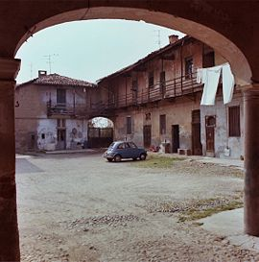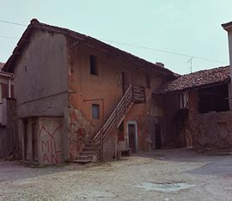
a Lombard courtyard.

Another well known movement was “The Rationalism”. The main artist was the architect G. Terragni from Meda. He lived and worked in Como, where he died at the age of only 39 years old. Terragni was the architect of some of the most meaningful Italian Rationalist architecture, such as “The Novocomum” building, the “Casa del Fascio” and “The Sant’Elia Nursery-school”, all in Como. This last one was dedicated to A. Sant’Elia, died in war when he was just 28.

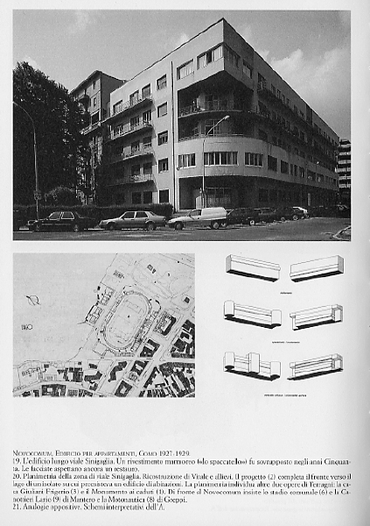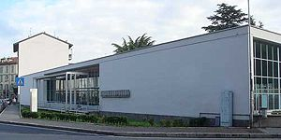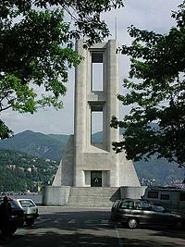
Novocomum. St. Elia Nursery-school. War Memorial in Como.

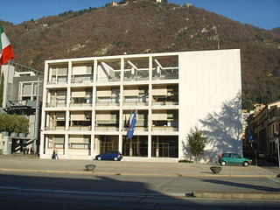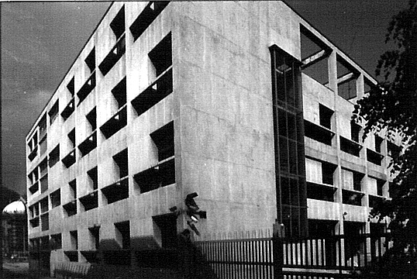

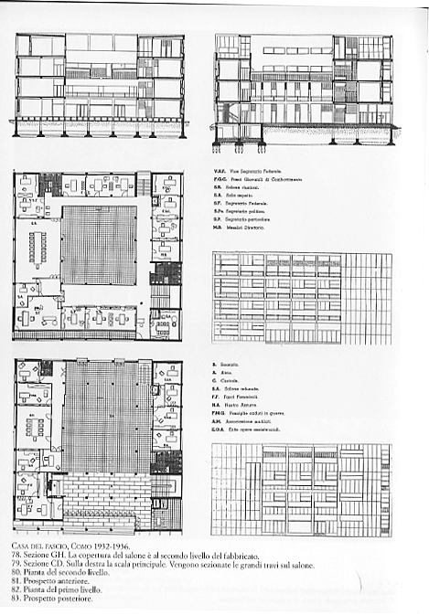

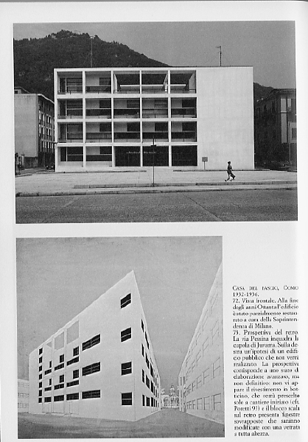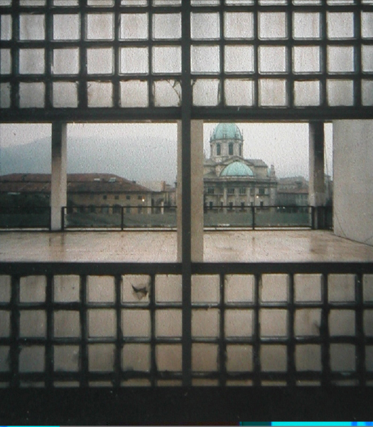
Casa del Fascio

Terragni was not only an architect. He projected also interior furnitures and made paintings. It’s the birth of “Design” in Italy.

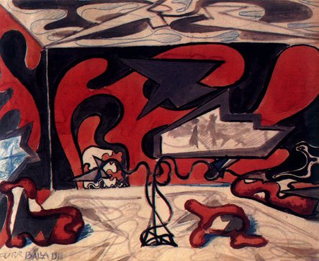
a project of a living room.

Some years later was born “The Abstractism”: in Como we have had famous artists like Radice, Rho, Galli, Badiali, Sartoris and so on.
We can’t finish without telling you something about our sculptor Adolfo Wildt. He established a commemorative work, “The War Memorial”, dedicated to that soldiers died during the war. It is in our Piazza Libertà” in Appiano G.le, no far from St. Stefano’s Church.
Wildt was also author of the “Garden’s Fountain” of Villa Reale in Milan.

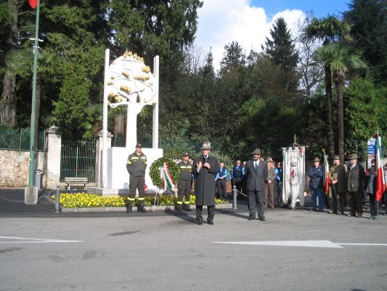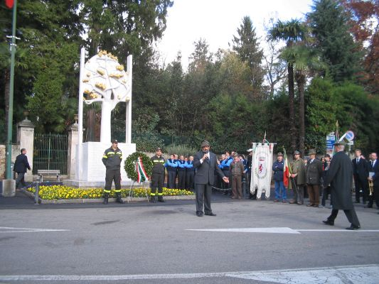
Wildt’s War Memorial in Appiano.

Comenius Project

LOMBARD ARTISTS
OF THE XX CENTURY

Class 4^ A





